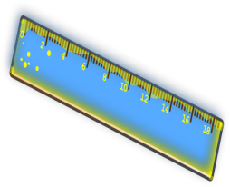http://www.google.fr/url?source=imglanding&ct=img&q=http://1.bp.blogspot.com/-C3lzoyLk4J8/T_YJSmSDD1I/AAAAAAAACXg/gke8K5xzjPI/s1600/pencil_color4.png&sa=X&ved=0CAkQ8wc4ImoVChMIgreqsdOKxgIVQ1ssCh2B2wAN&usg=AFQjCNG9JdLPfFBMvQ69SntwdoHkQEQK6Q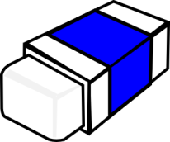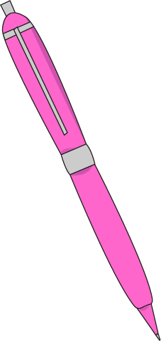http://www.google.fr/url?source=imglanding&ct=img&q=http://1.bp.blogspot.com/-C3lzoyLk4J8/T_YJSmSDD1I/AAAAAAAACXg/gke8K5xzjPI/s1600/pencil_color4.png&sa=X&ved=0CAkQ8wc4ImoVChMIgreqsdOKxgIVQ1ssCh2B2wAN&usg=AFQjCNG9JdLPfFBMvQ69SntwdoHkQEQK6Q

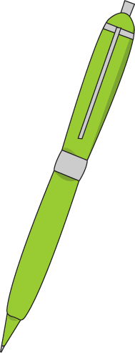http://www.google.fr/url?source=imglanding&ct=img&q=http://1.bp.blogspot.com/-C3lzoyLk4J8/T_YJSmSDD1I/AAAAAAAACXg/gke8K5xzjPI/s1600/pencil_color4.png&sa=X&ved=0CAkQ8wc4ImoVChMIgreqsdOKxgIVQ1ssCh2B2wAN&usg=AFQjCNG9JdLPfFBMvQ69SntwdoHkQEQK6Qhttp://www.google.fr/url?source=imglanding&ct=img&q=http://1.bp.blogspot.com/-C3lzoyLk4J8/T_YJSmSDD1I/AAAAAAAACXg/gke8K5xzjPI/s1600/pencil_color4.png&sa=X&ved=0CAkQ8wc4ImoVChMIgreqsdOKxgIVQ1ssCh2B2wAN&usg=AFQjCNG9JdLPfFBMvQ69SntwdoHkQEQK6Q

http://www.google.fr/url?source=imglanding&ct=img&q=http://1.bp.blogspot.com/-C3lzoyLk4J8/T_YJSmSDD1I/AAAAAAAACXg/gke8K5xzjPI/s1600/pencil_color4.png&sa=X&ved=0CAkQ8wc4ImoVChMIgreqsdOKxgIVQ1ssCh2B2wAN&usg=AFQjCNG9JdLPfFBMvQ69SntwdoHkQEQK6Q





http://www.google.fr/url?source=imglanding&ct=img&q=http://1.bp.blogspot.com/-C3lzoyLk4J8/T_YJSmSDD1I/AAAAAAAACXg/gke8K5xzjPI/s1600/pencil_color4.png&sa=X&ved=0CAkQ8wc4ImoVChMIgreqsdOKxgIVQ1ssCh2B2wAN&usg=AFQjCNG9JdLPfFBMvQ69SntwdoHkQEQK6Q

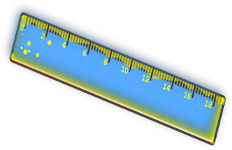

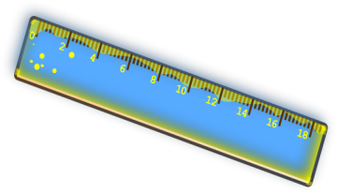

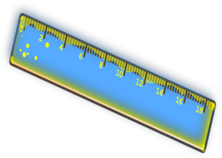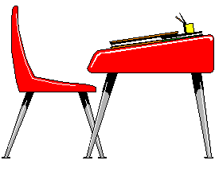

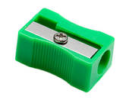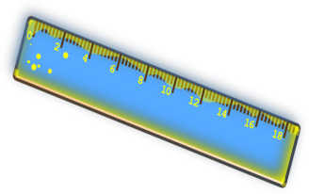

http://www.google.fr/url?source=imglanding&ct=img&q=http://1.bp.blogspot.com/-C3lzoyLk4J8/T_YJSmSDD1I/AAAAAAAACXg/gke8K5xzjPI/s1600/pencil_color4.png&sa=X&ved=0CAkQ8wc4ImoVChMIgreqsdOKxgIVQ1ssCh2B2wAN&usg=AFQjCNG9JdLPfFBMvQ69SntwdoHkQEQK6Q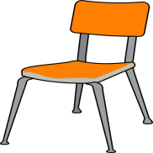

http://www.google.fr/url?source=imglanding&ct=img&q=http://1.bp.blogspot.com/-C3lzoyLk4J8/T_YJSmSDD1I/AAAAAAAACXg/gke8K5xzjPI/s1600/pencil_color4.png&sa=X&ved=0CAkQ8wc4ImoVChMIgreqsdOKxgIVQ1ssCh2B2wAN&usg=AFQjCNG9JdLPfFBMvQ69SntwdoHkQEQK6Qhttp://www.google.fr/url?source=imglanding&ct=img&q=http://1.bp.blogspot.com/-C3lzoyLk4J8/T_YJSmSDD1I/AAAAAAAACXg/gke8K5xzjPI/s1600/pencil_color4.png&sa=X&ved=0CAkQ8wc4ImoVChMIgreqsdOKxgIVQ1ssCh2B2wAN&usg=AFQjCNG9JdLPfFBMvQ69SntwdoHkQEQK6Q

http://www.google.fr/url?source=imglanding&ct=img&q=http://1.bp.blogspot.com/-C3lzoyLk4J8/T_YJSmSDD1I/AAAAAAAACXg/gke8K5xzjPI/s1600/pencil_color4.png&sa=X&ved=0CAkQ8wc4ImoVChMIgreqsdOKxgIVQ1ssCh2B2wAN&usg=AFQjCNG9JdLPfFBMvQ69SntwdoHkQEQK6Q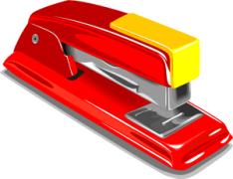

*trousses - ciseaux- chaises- taille-crayons - poubelles – crayons – colle- sac à dos- gommes- tableaux - cahiers –règles - livres -stylos- bureaux – crayons de couleur*

